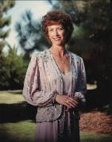
Linda Sophie Fish Richburg CSUF 1962

My name is Linda Sophie Richburg. I was born in Selma, CA, the older of 2 children born to Kent and Annette Fish. I attended Orange Cove grammar school, Reedley High School, and CSUF. I received my Bachelor of Science in Nursing at CSUF in 1962, the first nursing class to graduate.

I married Dr. Frederick Allen Richburg January of 1962. We have 4 children: our oldest son, Allen, is a sports medicine doctor. He lives in San Diego and has one son, Frederick Allen Richburg, III. We call him AJ. Our daughter, Cindy, is an attorney and lives in Sacramento. She has a daughter, Helena, 6 years old, and twin sons, Hunter and Christian, who are 3 1/2. We have 2 sons who live in Fresno: Brian is in commercial real estate and has 2 little girls, Sasha and Roxie, 4 and 2 ½ . Greg owns his own computer company called Netricks and has one daughter, Giana, who is one year old.

After our children started school, I worked with my husband in our ambulatory surgical center called the Richburg Valley Eye Institute.

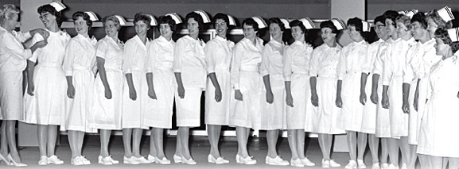
Now we are retired and are enjoying our 7 grandchildren. I also enjoy traveling, gardening, reading and playing classical music on my piano.

