RoseMarie Sandoval Fresno State 1988, 1993

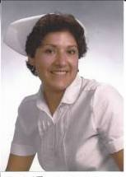
My name is RoseMarie Sandoval; I was born in Healdsburg, California. I was 3rd of six children born to Marina Conrique and Leo Sandoval (1st generation Mexican). I was the first to go to college in my family and the only nurse. I graduated from Hartnell College in Salinas as a registered nurse. I met Mike Russler, a recruiter from Fresno. When I graduated, I transferred to Fresno State and graduated in 1988 with my Bachelors in Nursing and in 1993 with my Masters in Nursing. I married Lester Wickman and have two beautiful Labradors, Tank (yellow) 140 lbs. and Coco (chocolate) 96 lbs. During the summers, I would return home to Hollister, California and work part-time as a staff nurse, another summer as a public health nurse and during my thesis I stayed in Fresno and worked at Sierra Community Hospital. Presently, I am working with a cardiologist Dr. Cheung K Tom Leung. We have been working together for 15 years.

The following statements have influenced my life and help me to understand the true meaning of self-awareness and service to others, “Go to school; don’t be like me”, “I can do that, but how do I get there?”, “Never stop learning”, “There is still much more to do”, “What is my next journey?”

I was raised with five siblings, by my single mother. My father was first generation from Mexico and a farm laborer. My father left us when we were very little. As a single mother, we could see how it affected my mother, always asking for favors. We cleaned churches for a break on the rent. You could say I had an “old soul” because at a young age, I could see what being a single parent was doing to my mother. Thank goodness for Grass Roots, an organization in the early 60’s that helped us with clothes, staples for living and food. We were poor and we felt the stigma. My mother would often tell us to “go to school” and not be like her, poor, uneducated and on welfare.

In high school, I studied to be a nursing assistant through the ROTC program. I worked in a local nursing home while going to high school. I learned to care for the elderly. I found my niche, I loved these people. They were my mentors, my guidance to what was eventually ahead for me. My supervisor, Mrs. Ella Jensen was the charge nurse. We respected and feared her. She had a sense of insight in caring for the elderly that will follow me for the rest of my life. One day Mrs. V was dying and we were all aware that Mrs. V was alone with no family. Mrs. Jensen explained that no one should die alone. She explained this lady was a human being who loved and laughed like all of us and needed to be loved. From then on, I treated every person as having a purpose in life and deserving to die with dignity and peace. I worked for five years as a nursing assistant and was given some nursing responsibilities (remember this is 1972) so I became interested in nursing. I was encouraged to go to school by another mentor Harriet Hegg RN.

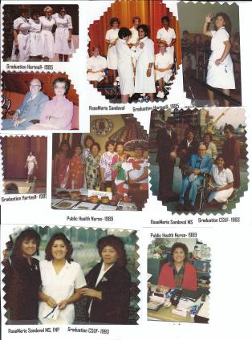
While in nursing school, at Hartnell, my instructor Julie Garvin would often tell us “never stop learning”. She told us to always keep abreast of the knowledge that was changing. I went to Fresno State for my Bachelors of Science and I returned to Gilroy to work part-time as a public health nurse. That is when I met Felynn a NP in a clinic. I saw her exam patients and order medications. I was intrigued with the one-to-one care and independence so again, “how do I become a nurse practitioner?” I returned to Fresno State to pursue the Family Nurse Practitioner program. I graduated with my masters in 1993. That is when I met Dr. Leung; my mother’s cardiologist. I have had the honor of working 15 years for Dr. Leung. Dr. Leung encompasses the spiritual and the human side of people. I have incorporated my own sense of practice and use my God given talent to understand the “whole person”.

In all my experiences, I have noted some important issues. We are living longer into the golden ages past 70’s, 80’s, and 90’s. I would often ask my patients if they could change something about their lives and they would state two. Take better care of themselves and not retire too early. Some regretted retiring early because they felt they could still contribute to the work force. Some advice I would give to students interested in nursing, get advice and guidance. I did it the long, hard way (although I would not change one thing, I had fun!), but there is an efficient way. Never give up; just the passion and persistence will get you where you need to go. I mentor students into nursing or medicine. I lead by example and try to make a difference. I love what I do and I get paid!

