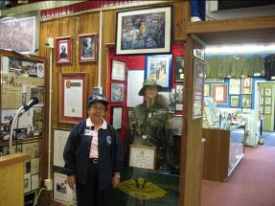
Carolyn Tanaka FSC 1965

My name is Carolyn Hisako Tanaka. I am 72 years old and was born in Santa Maria, California. I lived on a ranch in Guadalupe, California until WWII broke out and all Japanese Americans on the west coast were herded up and sent to internment camps across the United States. Our family was sent to Poston, Arizona for three years. Even at that young age I could not understand why we American citizens were put in these camps. This was one of the biggest mistakes our government made in history. It took our country over forty years to admit it had made a mistake and try to compensate us for the internment. It was NOT the money we wanted, but an apology from our government and an admission that it had made a terrible mistake. We loved our country and the men and some women went off to war to prove we are truly American citizens.
My hero in Guadalupe was cousin, Abraham Abe Ohama, who went from camp to join the 442nd Regimental combat Team. He used to baby sit me, and my aunt told me that I followed Abe everywhere he went. I remember him putting me on his broad shoulders and romping with me on Pismo Beach. He was sent to Europe from camp when he joined the famous 442nd Regimental Combat Team, going from Italy to France. Near Bruyes, France, he took a bullet from a German soldier that took his life when he went under heavy fire to rescue a comrade who was trapped behind enemy lines. He was awarded the Silver Star for his heroism. This unit was the most decorated unit in military history.
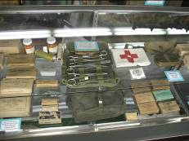
After WWII, our family moved to Fresno to start life anew. This is where my mother, Helen Iwata, was born and raised…Our home in Guadalupe had been burned to the ground by Japanese haters while we were in camp, so we had no home to return to. I finished grammar school at Lincoln Elementary School. Because we lived on a farm, I had to go to Fresno Colony Elementary School in the seventh and eighth grades, while my church friends went to Edison High. I joined them in the ninth grade and graduated from Edison in 1953. I started college at Fresno State for two years as a PE major, but mother told me there was no future for a female athlete and I should consider going to nursing school where cousin, Miya was graduating.
Therefore in September of 1958, I applied for a scholarship and was awarded a full three years scholarship to the Fresno General Hospital School of Nursing. This was given to me by the Ladies Auxiliary to the Fresno/Madera County Medical Society. We all went to Sacramento to take our RN boards and we all passed. Therefore, I became a nurse instead of a PE teacher. I have never been married, but have had a few flings which shall remain a secret. During my three years in training, I lived in Huntington Hall, the nurse’s dorm at the time. Our class was the last for the FGH School of Nursing because the county said it did not get the nurses it wanted from our graduates.
As a student, I took care of a terminal patient who was Hispanic, and with whom I conversed each day. I cared for him. He taught me a new word everyday, and by the time he passed away, I was pretty fluent in Spanish. I never got the chance to return to Japanese language school, so I am more fluent in Spanish than in Japanese.
My most vivid patient recollection in Vietnam was a man who lost his entire face from an exploding rocket. He had only been in Vietnam ten days when this accident took place. I stood over a patient without a face. My young nurses could not take care of him so it became my job. He wanted to communicate, but couldn’t, so I handed him a clipboard with a piece of paper on it and a pen with which to write. Without being able to see, he wrote the words, “NO FACE”.
Over the years I had no recollection of this patient until my daughter, Arline Martinez, was reading an issue of People Magazine. She asked me, “Isn’t this the patient you took care of in Vietnam?” I looked, and sure enough it was. People Magazine could not give me any information on him, so I called my friend Nancy Osborne of Channel 30. Through her media contacts she found him, but she asked me to wait one day because she wanted to record our conversation, but she had to cover the elections that day. She came to my office at VMC with her cameraman and I placed the call. I stayed up all night wondering what I was going to say to him. However, the conversation came easily as we talked about Hoosier football and basketball, and I told him about my interests in sports.
Then in 1993, when the Vietnam Women’s Memorial was to be dedicated, I again wrote to People Magazine and asked them to pay the expenses for Rory and whoever needed to accompany him from Valpariaso, Indiana to Washington, DC. They were interested in doing a story on our meeting, so agreed to pay their expenses, that was the most memorable experience in my 32 years nursing career. I picked them up in a taxicab each morning, took them to breakfast, lunch and dinner and back to their hotel, after touring the city.
I held jobs at FGH, VMC, and UMC from staff nurse on up to interim Director of Nurses. My most significant contributions in my 32 years of work there happened between 1973 to 1980 when I was with the Outpatient Department, and was asked to oversee the 7 year project of remodeling that was happening. During those seven years, I started clinics in Mendota, Fresno County Jail and Industrial Farm, Juvenile Hall, the move of the Family Practice Clinic to Huntington Hall, the building of the new Children’s Clinic and the remodeling of the emergency department from small 5 exam rooms to the enlarged 32 exam rooms. I had to find storage space for all the old furniture, and make room to store the new furniture until the remodeling was completed. I used every space I could find and cleared out others to make room. My Vietnam experience came in handy as I scrounged for furnishings. Mr. Jett, the auctioneer asked, “Who is this Tanaka person who is taking all my furniture?” I had labeled every piece of furniture I could find to save with my name on it for the reconstruction project.
In September, 1966, I joined the Army Nurse Corps because they were the only unit who would guarantee me as assignment in Vietnam during my two year tour of duty. My two brothers had joined the Army that year, and I did not want to be the only Tanaka sibling who was not a veteran. My oldest brother was a Korean wartime veteran. I really joined the service because of my cousin, Abraham Abe Ohama, who died a Silver Star hero in France during WWII trying to save his buddy trapped behind enemy lines. Before he went on this mission, he told his other sergeant, Jack Wakamatsu, “I’m not coming out of this mission alive, so when the war is over, I want you to write a book about that we’re doing here because it is an important part of America’s history.” It took Jack until 1984 to get his book, “Silent Warriors” published, and cousin, Abe is mentioned throughout this book. Since I had my BSN and eight years of nursing experience as an RN, I was given the rank of Captain. I had plenty of training taking care of automobile accident victims, GSWs and SWs at FGH in the ER. But nothing prepared me for what I was to see in Vietnam. The weapons of war are designed to mutilate the human body, so you don’t just have a through and through GSW, but you are faced with multiple organ systems among the wounded in any war.
The Army Nurse Crops was the best training I ever received. I came home from Vietnam in September, 1968. I thought I had done my duty for my country and would not have anything more to do with the military. That held true until I received a call from the Vietnam Women’s Memorial Project in 1986, asking me to become a volunteer for the Project to help raise funds.
I went to the phone directory and got a military directory and began writing hundreds of letters to get invited to speak and raise funds for our Memorial. I never asked for money, but most of the organizations gave me a check for my speech which I forwarded to the Project. I paid my own expenses and sent every bit of money collected to the Project. I went to Washington, DC with my daughter Arline, for the dedication of our Memorial. While we were back east a few days early, I had her drive us through upper New York State and across to Niagara Falls. We then came down to Washington, DC.
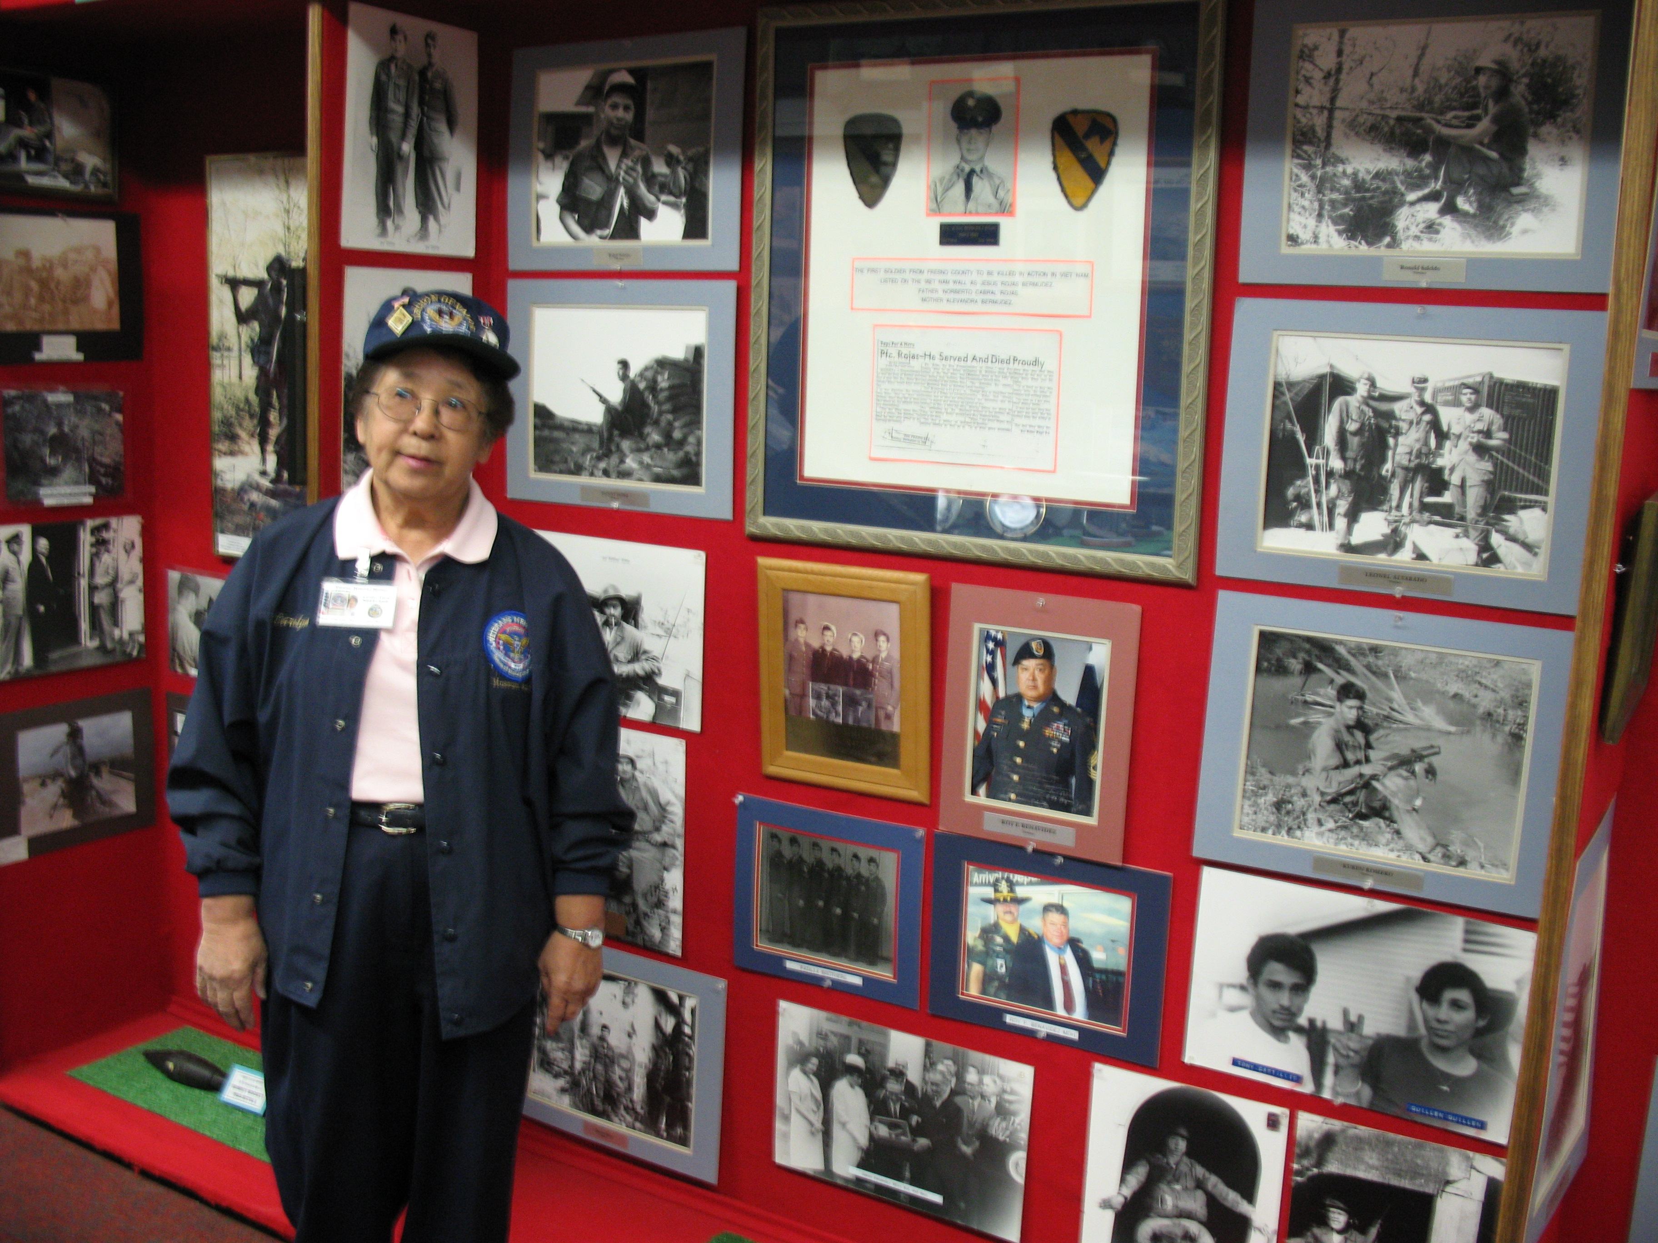
I did not hear from any of my nurses until I joined the Project and started searching for them. The Army Nurse Corps taught me about discipline, service and perseverance. After Nam, I remained a civilian until one day in 1994, as I was walking across a parking lot on the way to a movie, and I heard this booming voice behind me calling my name. I turned around and it was Chuck Monges, founder of the Legion of Valor Museum in the old civic auditorium on the corner of Fresno and O streets. He told me to come and take a look and see because he wanted to add women in this museum. So again, I wrote to as many women veterans I knew to get pictures and stories to put in the museum. I put up the women’s display as it is today. In 1993, I joined the Vietnam Nurses Haven, and now communicate with them on a daily basis on the computer.

