Quick Guide to CWS/CMS

Release 6.2 Changes



Central CA Training Academy

Terry Luna, CWS/CMS Training Project Coordinator
559-278-5757
terril@csufresno.edu

Quick Guide to 6.2 Changes

Changes in Referrals

Attaching Adopted Children to New Referrals Page 3

Referral Reminders Page 3

Changes in Cases

Attaching Adopted Children to Cases Page 4

FC Annual Redetermination Reminder Page 4

Changes in Placement Page 5

Changes in the Client Notebook

Id page Page 6

Demographic Page 7

Health Notebook

Summary Page Page 8

Medications Page Page 9

Immunizations Page Page 10

Family Information Notebook

Recording the Legal Designation of Father Page 11

Court – 32 JV Documents Added Page 12

ICWA – Producing the ICWA-030 Page 13-17

Adoptions Page 17-18

Cannot Attach a Child with a Finalized Adoption to a New Referral:

User will get an error message when attaching a child to a New Referral, if they are currently in an Adoptive Placement. This will prevent the child’s pre-adoptive history information from being linked with this post-adoptive referral.
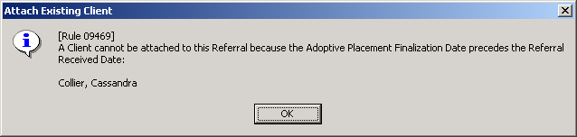

Referral Reminders will no longer be Filtered:

When disposing a Referral – worker will no longer have to go to the Filter button in order to display all reminders. All required reminders will automatically display.

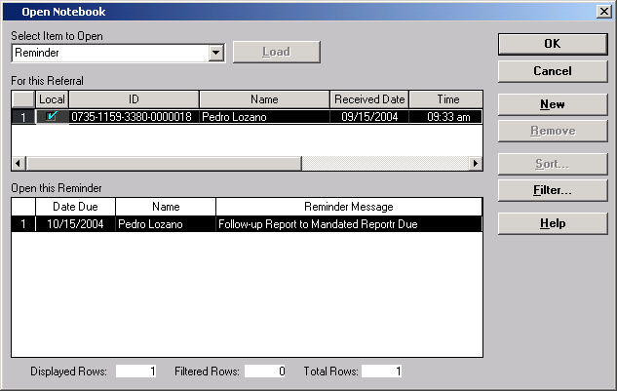
Changes in Cases:

Cannot Attach a Child with a Finalized Adoption to a New Case:

User will no longer be able to attach a child to a case if the child has an adoptive placement that is prior to the case open date. The child will also not be able to be selected as a Focus Child when opening a case without promoting from referral. This will prevent linking pre and post adoptive history for a child.
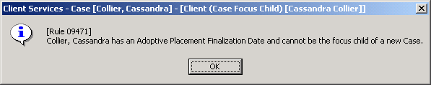
FC Annual Redetermination – Reminder Updated

The FC2 – Redetermination reminder has been changed to reflect current regulations requiring an annual redetermination. In order for the reminder to be generated, the AFDC-FC page must be completed to show the FC effective date or redetermination date. The reminder will generate eleven months from the most recent determination date.

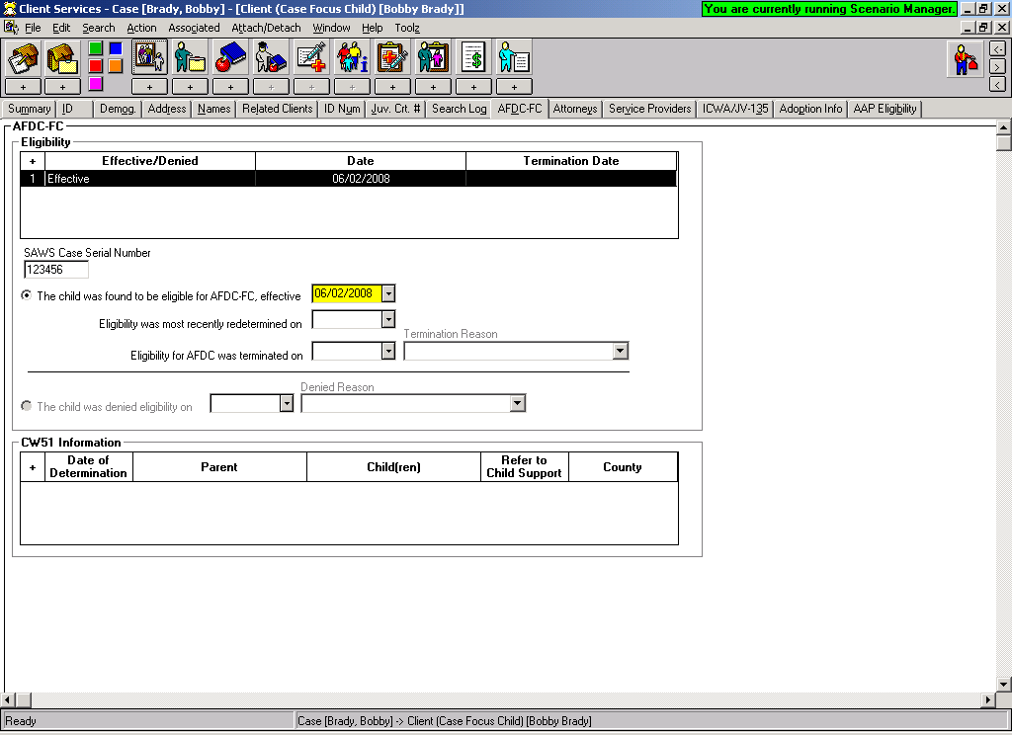

The reminder will display in the GREEN section – under the Reminder notebook:
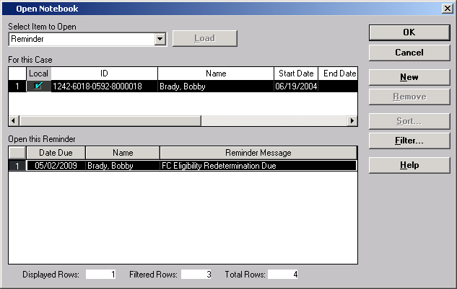

Changes in Placement:

Two Placement Episode Termination Reasons have been disabled:
- Child Ran Away From Placement
- Child Refused Services

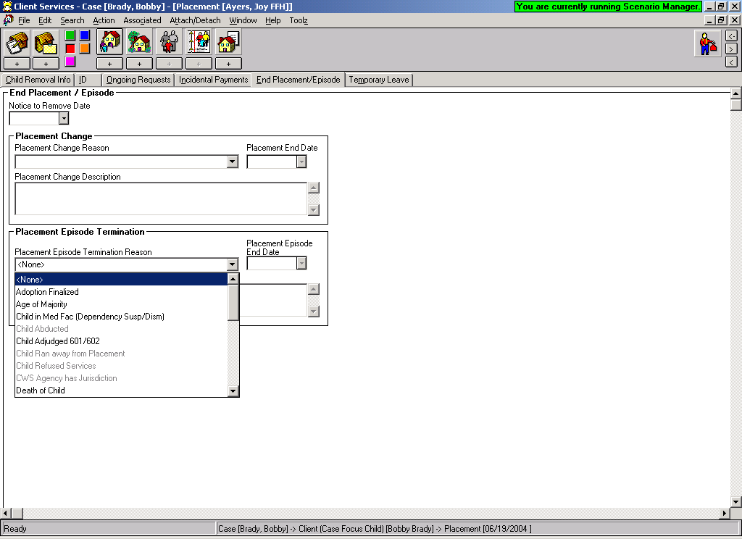
Changes in the Client Notebook:

ID Page

The Hispanic or Latino Origin button will no longer default to undetermined.
Worker must select the appropriate button. A message will display in RED when the button has not been checked and Hispanic has been checked in either primary or secondary ethnicity. The message will also display when Hispanic origin button has been selected but does not correspond with primary or secondary ethnicity.

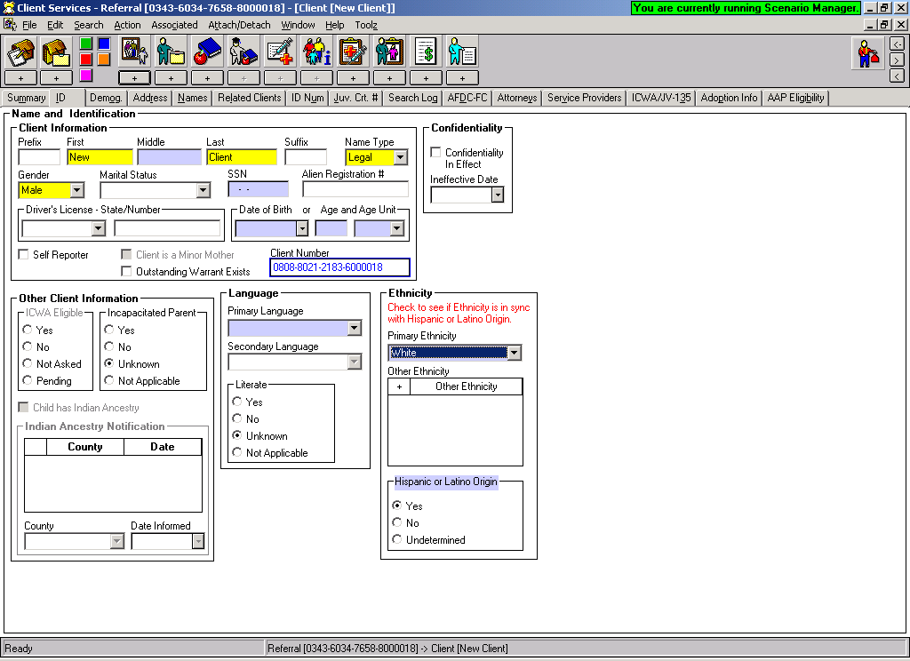

Demographic Page:

The ‘Previously Adopted’ radio button field located at the bottom of this page is now color-coded GREEN to remind worker that this is an AFCARS field. If not completed, the user will still be able to save to database, however, if the user has the information, it should be completed.

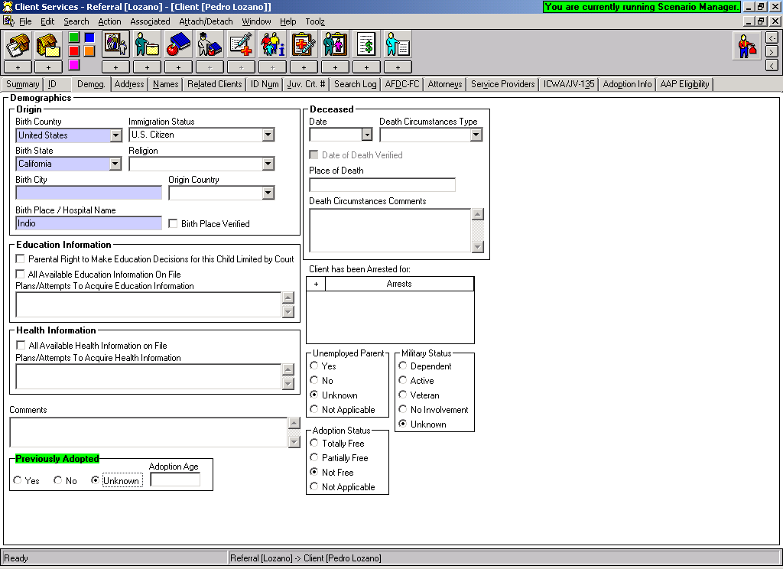

Changes in the Health Notebook:

Summary Page
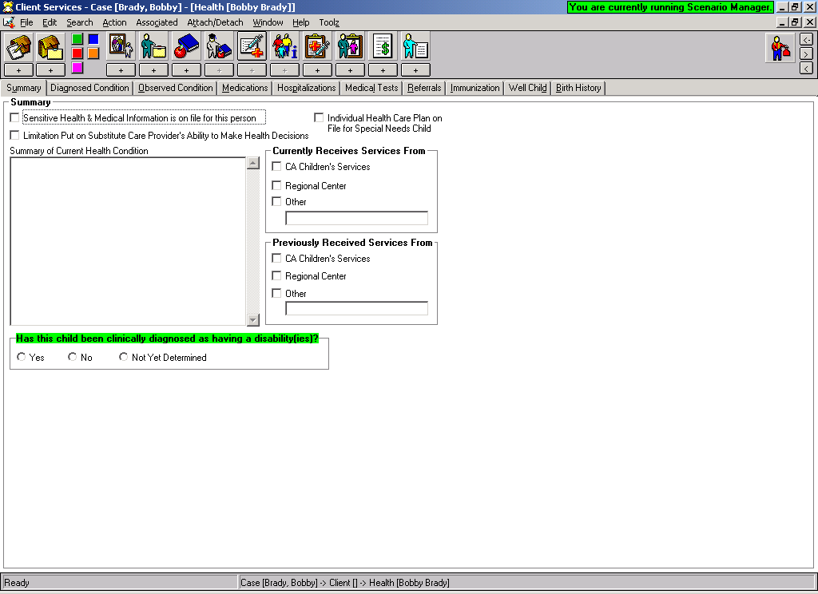
Now includes the ability for worker to document if child has been clinically diagnosed as having a disability – it is color-coded GREEN to indicate a new AFCARS field.

Medications Page:
This page has been updated to allow more flexibility in recording psychotropic medications. 2 radio buttons have been added to indicate if the medication is a psychotropic medication and an indicator if the medication is prescribed for psychiatric purposes.
A new grid has been added that will allow the retention of court order/parental consent dates.
Reminders have been designed to:
Remind worker in the event a medication is psychotropic/used for psychiatric purposes and no court order exists – that a court order is due.
Remind worker one month prior to a court order expires that another is coming due.

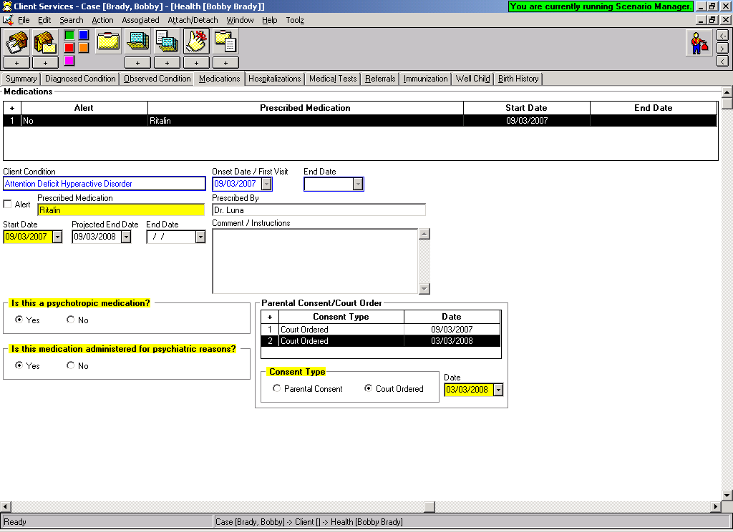

Immunizations Page:

The list of Immunizations has been updated with more values, and arranges them in the same order as the yellow immunization card.

Worker now has the ability to choose ‘All Immunizations Waived’.

If TB Test is chosen under the Immunization list – the worker can also indicate the result here.
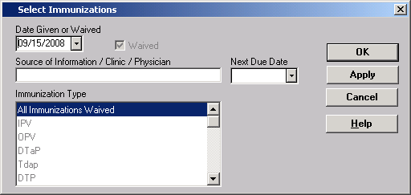
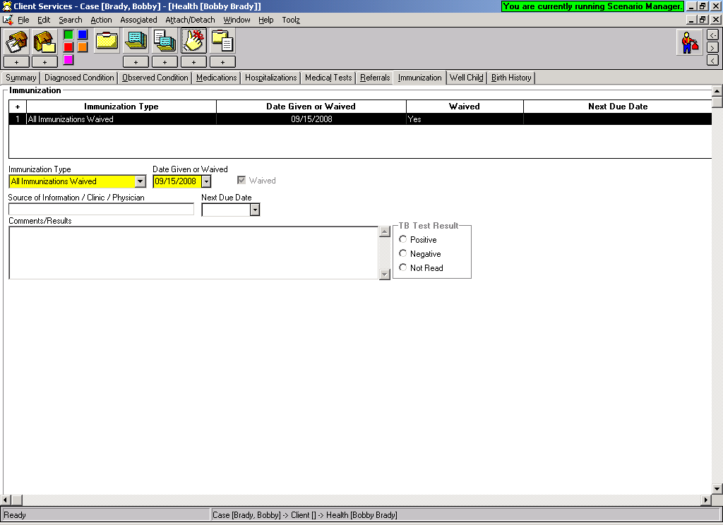

Health & Education Passport and the Medi-Cal Application – MC250 have now been updated to the 5/07 version.
Family Information Notebook:

Paternity Page
User will now have the ability to choose a “Legal Designation’ for father – either Alleged or Presumed. This action will update the Related Clients page for the father/child relationship.
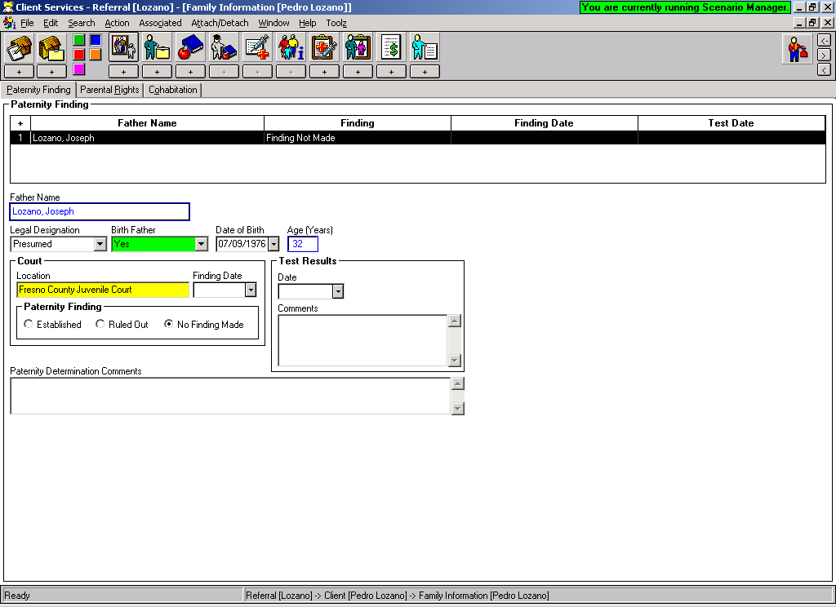
The Birth Father field will turn GREEN – and worker can select Yes/No or Unknown.

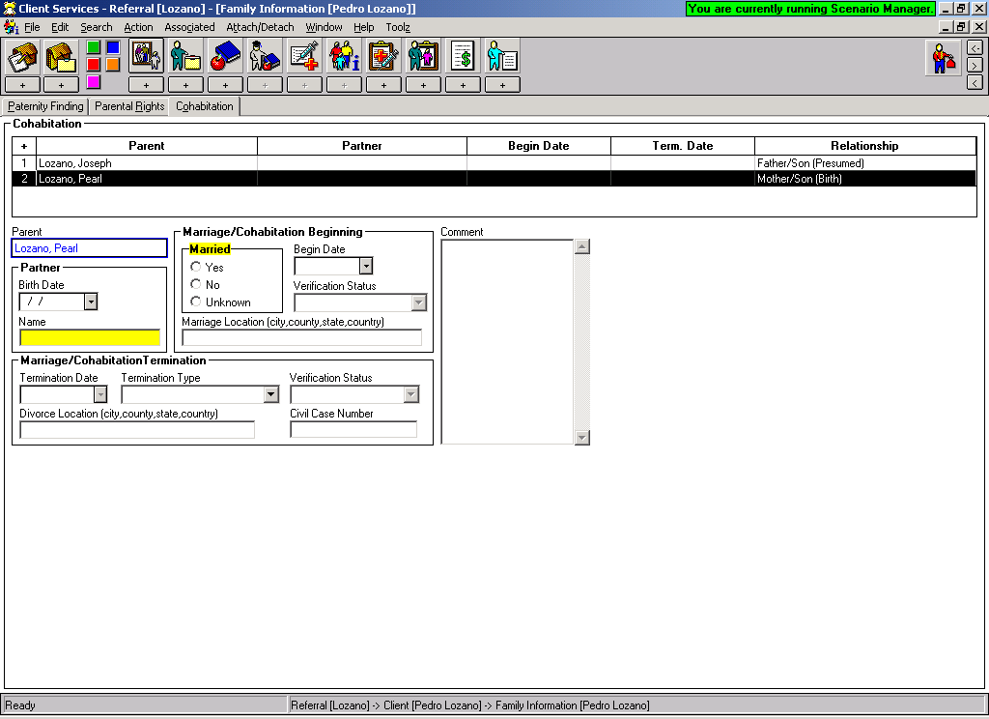
Cohabitation Page: Married/Cohabitation field will no longer default to unknown and is now a mandatory field.
Changes in the Court Section: 32 additional JV Documents added.

The following JV documents will be added to the application in the Hearing notebook:
- JV 400- Visitation Attachment: Parent, Legal Guardian, Indian Custodian, Other Important Person (Available from Referral)
- JV 401- Visitation Attachment: Sibling (Available from Referral)
- JV 402- Visitation Attachment: Grandparent (Available from Referral)
- JV 405- Continuance-Detention Hearing (Available from Referral)
- JV 406- Continuance-General (Available from Referral)
- JV 410- Findings and Orders After Detention Hearing (W&I Code, § 319) (Available from Referral)
- JV 412- Findings and Orders After Jurisdictional Hearing (W&I Code, § 356)
- JV 415- Findings and Orders After Dispositional Hearing (W&I Code. Code, § 361 et seq.)
- JV 416- Dispositional Attachment: Dismissal of Petition With or Without Informal Supervision (W&I Code, § 360(b))
- JV 417- Dispositional Attachment: In-Home Placement With Formal Supervision (W&I Code, § 361)
- JV 418- Dispositional Attachment: Appointment of Guardian (W&I Code, § 360(a))
- JV 419- Guardianship (Juvenile) -Consent and Waiver of Rights
- JV 419A – Guardianship (Juvenile) -Child's Consent and Waiver of Rights
- JV 420- Dispositional Attachment: Removal From Custodial Parent-Placement With Previously Noncustodial Parent (W&I Code, §§ 361, 361.2)
- JV 421- Dispositional Attachment: Removal From Custodial Parent-Placement With Nonparent (W&I Code, §§ 361, 361.2)
- JV 425- Findings and Orders After In-Home Status Review Hearing (W&I Code, § 364)
- JV 426- Findings and Orders After In-Home Status Review Hearing-Child Placed With Previously Noncustodial Parent (W&I Code, §§ 364, 366.21)
- JV 430- Findings and Orders After Six-Month Prepermanency Hearing (W&I Code, § 366.21(e))
- JV 431- Six-Month Prepermanency Attachment: Child Reunified (W&I Code, § 366.21(e))
- JV 432- Six-Month Prepermanency Attachment: Reunification Services Continued (W&I Code, § 366.21(e))
- JV 433- Six-Month Prepermanency Attachment: Reunification Services Terminated (W&I Code, § 366.21(e))
- JV 435- Findings and Orders After 12-Month Permanency Hearing (W&I Code, § 366.21(f))
- JV 436- Twelve-Month Permanency Attachment: Child Reunified (W&I Code, § 366.21(f))
- JV 437- Twelve-Month Permanency Attachment: Reunification Services Continued (W&I Code, § 366.21(f))
- JV 438- Twelve-Month Permanency Attachment: Reunification Services Terminated (W&I Code, § 366.21(f))
- JV 440- Findings and Orders After 18-Month Permanency Hearing (W&I Code, § 366.22)
- JV 441- Eighteen-Month Permanency Attachment: Child Reunified (W&I Code, § 366.22)
- JV 442- Eighteen-Month Permanency Attachment: Reunification Services Terminated (W&I Code, § 366.22)
- JV 445- Findings and Orders After Postpermanency Hearing-Parental Rights Terminated; Permanent Plan of Adoption (W&I Code, § 366.3(f))
- JV 446- Findings and Orders After Postpermanency Hearing-Permanent Plan Other Than Adoption (W&I Code, § 366.3)
- JV 448- Order Granting Authority to Consent to Medical, Surgical, and Dental Care (W&I Code § 366.27)
- JV 365- Termination of Dependency Jurisdiction-Child Attaining Age of Majority

ICWA

ICWA-030 can be automatically generated from the Notices Page in the

Hearing Notebook (Any reference to JV 135 will be changed at next release) The actual document that will be produced is the ICWA-030.

Notices Page: When the JV 135 is selected, this box will appear on page:

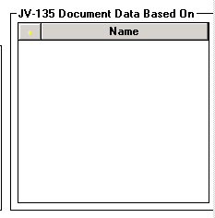
This box will allow worker to
choose who the data for the
ICWA-030 is based on.

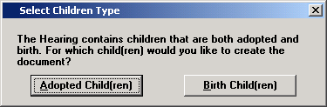
If the client notebook contains
children with adoptive relationship
as well as birth children, this dialog
box will appear - ICWA-030 must be
generated separately for each.

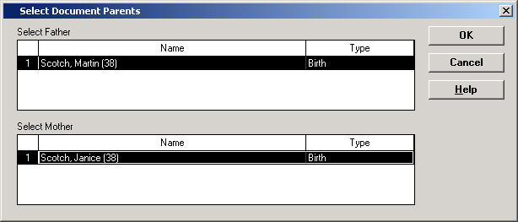
If Birth children selected,
then select parents from
this box.

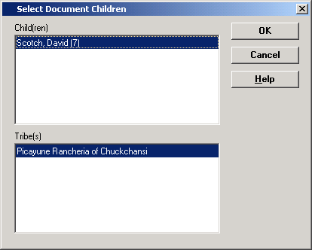
The ICWA-030 document is based on ‘full’ siblings – therefore the parents selected in this dialog will determine which children and tribes appear in the following box. The tribes populate from the ICWA/JV135 page of the client notebooks.

Select children and tribes
from this dialog.

Once the JV-135 Data Based on box has been completed, choose recipients of the notice in the usual way:
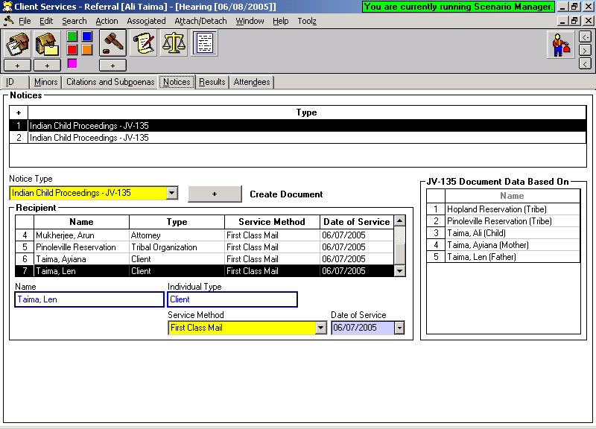

Then use the + Create Document to produce the ICWA-030.

This is the first dialog to appear – select the petitioner here.

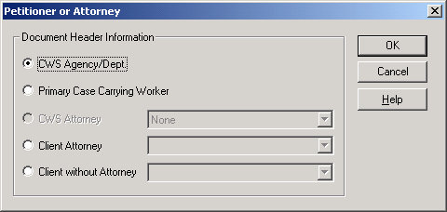
The next dialog will appear so that former addresses of parents can be selected. This information will populate to the ICWA-030.

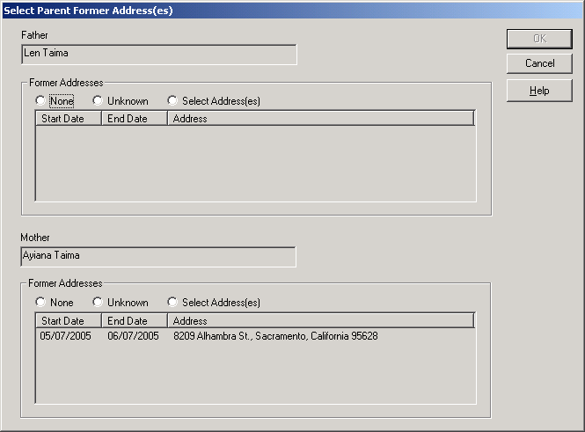

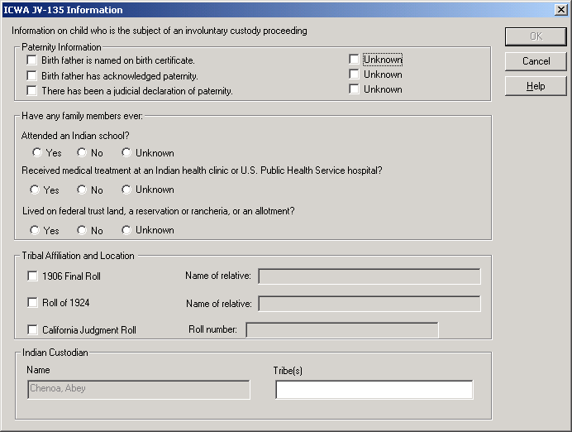
Paternity: at least
one check box
need to be checked
or all three unknown
checked.

Make the
appropriate
selections from the
rest of this dialog box.

This box will only appear if YES was selected to any of the questions in
center section of the previous dialog box. 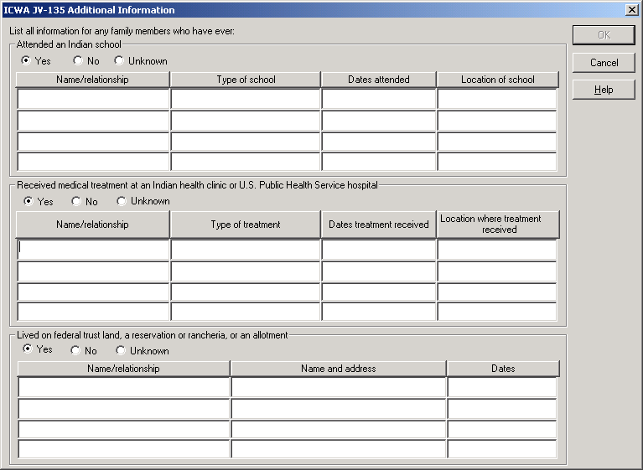

This box will appear with any grandparents listed from the ICWA/JV-135 page of the client notebooks. Any grandparent selected will populate to the ICWA-030.

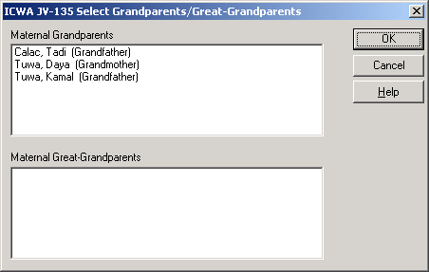

Worker will be able to select addresses for each recipient as usual .

Once the document is produced – the worker has capability of ‘unprotecting’ it in order to edit as necessary.

From TOOLS menu – select ‘Unprotect Document’. Edit document, and save.

The ICWA-030 is a saved document – it is stored in the same place as court reports.

Changes for Adoptions:

Family Information Notebook:

Paternity Page
User will now have the ability to choose a “Legal Designation’ for father – either Alleged or Presumed. This action will update the Related Clients page for the father/child relationship.
The Birth Father field will turn GREEN – and worker can select Yes/No or Unknown.

Information from this page will populate to the AD90/AD551A.

AAP Eligibility Page of Client Notebook:
Age of 3 years or older will no longer be checked automatically if it applies. Worker will now have to make the decision if it is applicable and check the box.
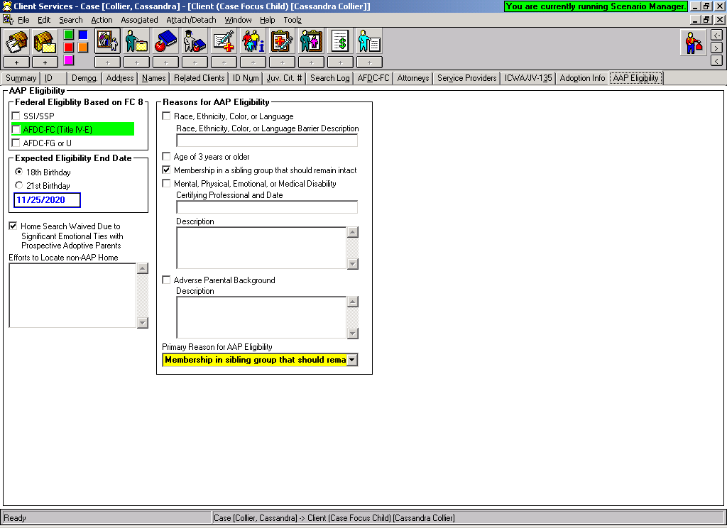

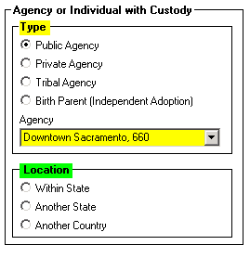

This new frame has been added to the Adoption Info page of the child’s client notebook.

Location section has been color coded GREEN to indicate a new AFCARS field.

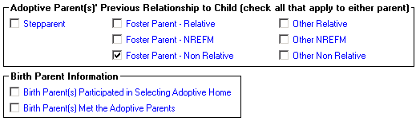
On the ID page of the Adoptive Placement notebook, 3 new options regarding relationship have been added.

